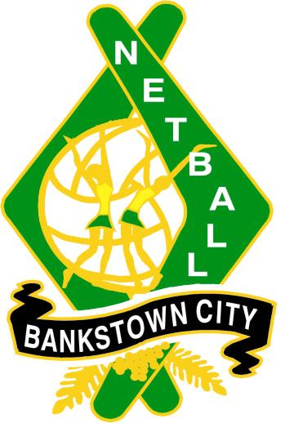
BANKSTOWN CITY NETBALL ASSOCIATION INC
NOMINATION FOR EXECUTIVE OFFICE BEARERS AND COMMITTEES
2024
Name
Affiliated Club

Phone number: |  | Email Address
WWC number:

EXECUTIVE POSITION | Select | EXECUTIVE POSITION | Select
President | ⎕ | Coaching Convenor | ⎕
Vice President | ⎕ | Competition Convenor | ⎕
Secretary | ⎕ | Registrar | ⎕
Treasurer | ⎕ | Representative Convenor | ⎕
Assistant Secretary | ⎕ | Umpires Convenor | ⎕
COMMITTEES | Select | COMMITTEES | Select
Competition Committee | ⎕ | Grading Appeals Committee | ⎕
Discipline Committee | ⎕ | Appeals Committee | ⎕
Grounds Committee | ⎕
OFFICE BEARER | Select
Publicity Officer | ⎕

Nominated by
Club | Name | Signature
 |  | Date
Seconded by
Club | Name | Signature
 |  | Date

I herewith accept this nomination:
Name | Signature | Date

Send form to: Email: bcnamarketing@bankstowncitynetball.com
NOMINATIONS CLOSE 5.00pm 30th SEPTEMBER 2024

